**Beginner project on how to host a Static website on aws:**

**The first step is to purchase a domain name for Route 53 and wait for aws to register it.**

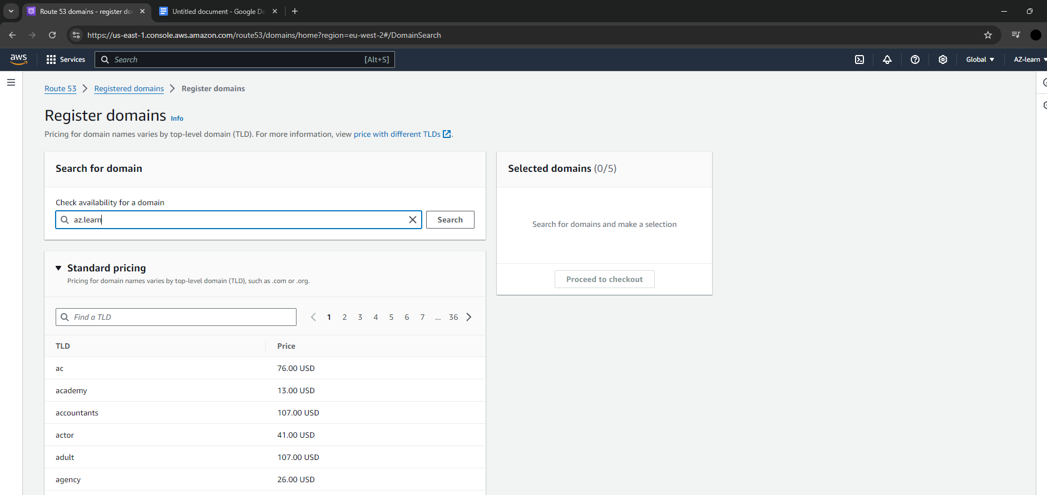

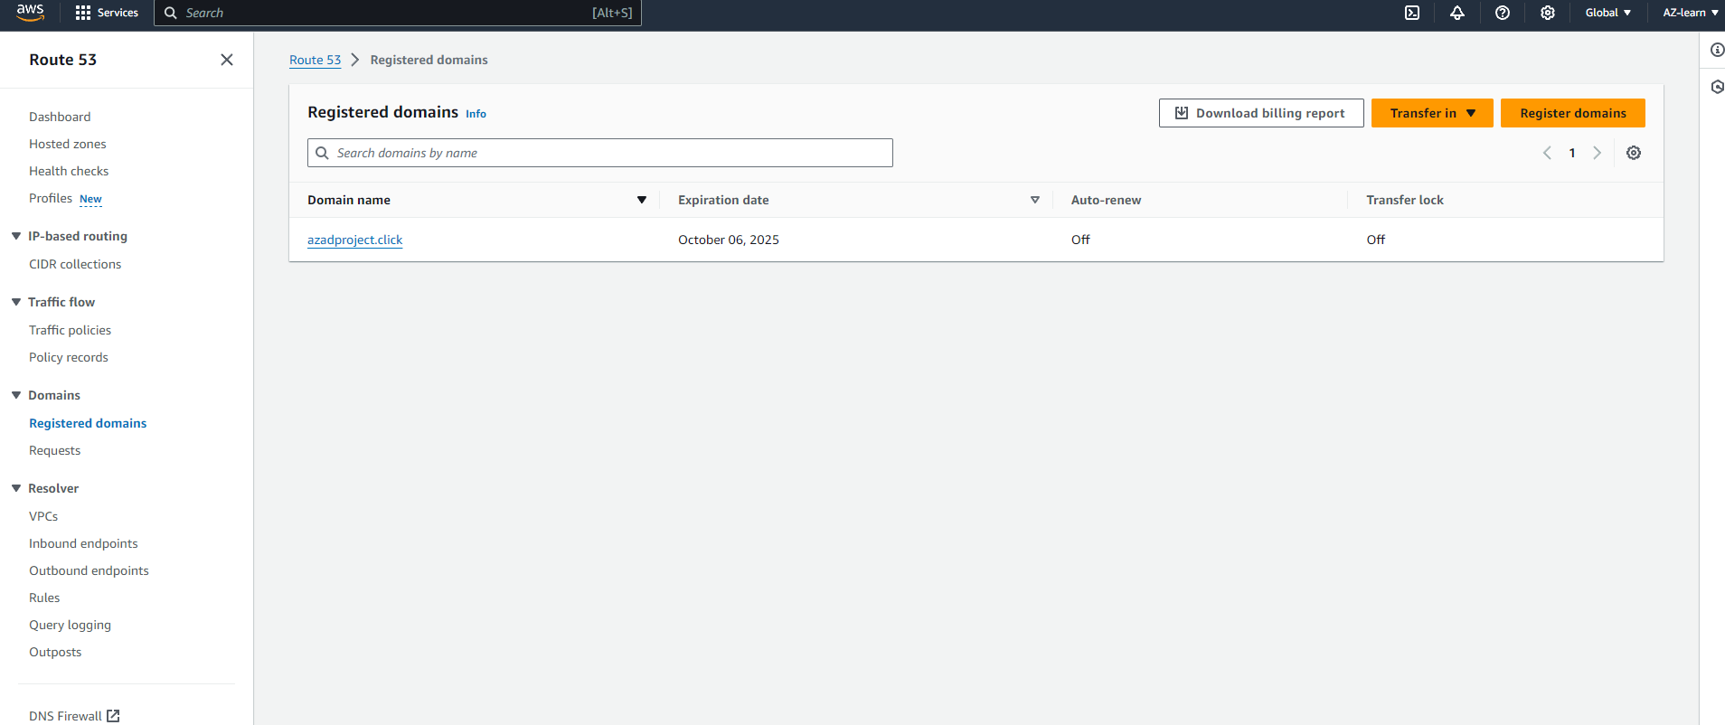

**The next step is to make a S3 bucket with the same name as your domain name and also pick the region closest to you to reduce latency.**

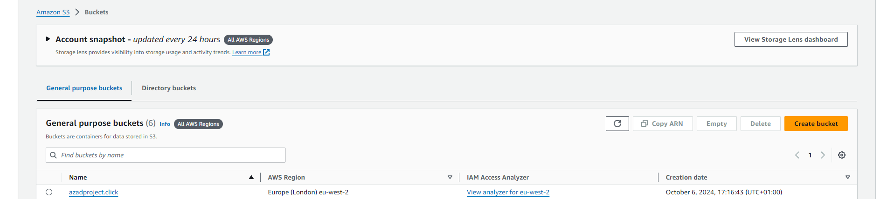

**After your bucket has been created click on it and upload your website, you can code your own website or find a website file online.**

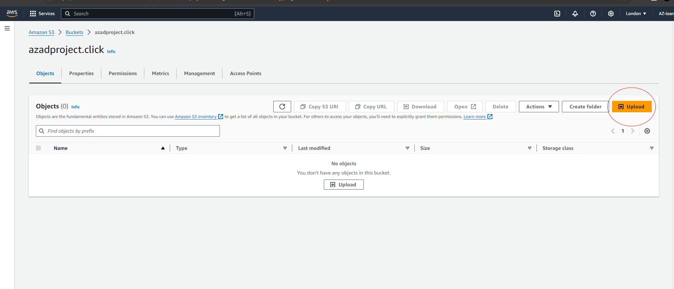

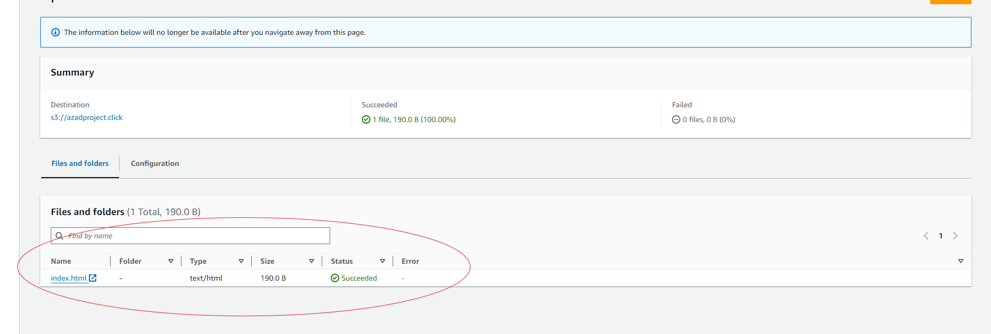

**Now we need to make sure this website is enabled for static website hosting and also that it has the right permissions for users to access it.**

**To do this we need to go on properties and scroll down to static website hosting and enable it.**

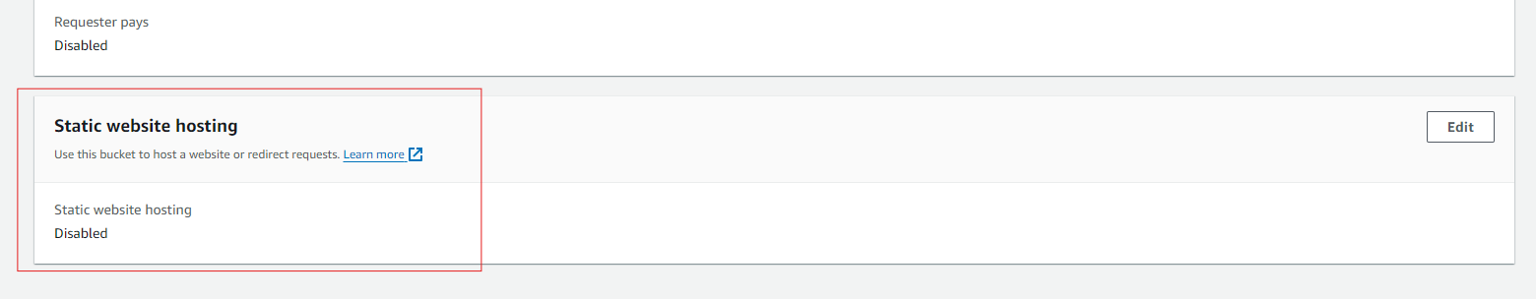

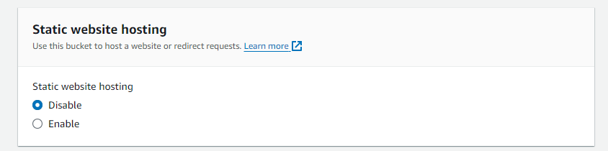

**After you click enable a few other option will pop up, in the section where it says index document ,write the website file you have upload to your S3 bucket**

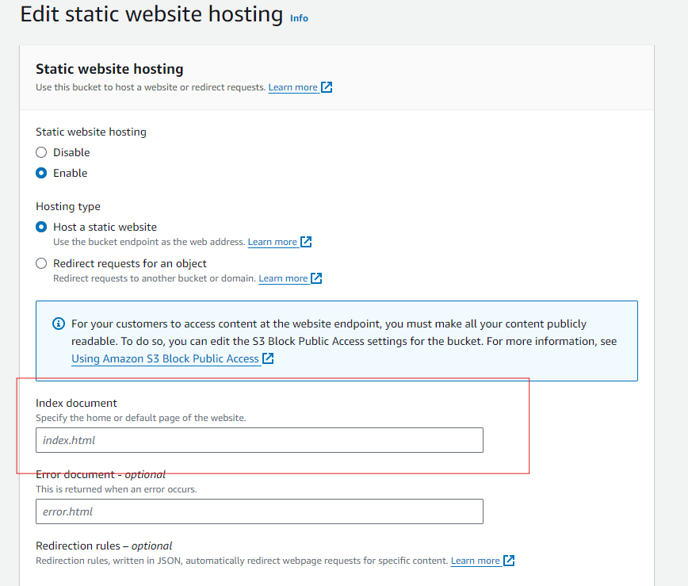

**Next step is to attach a bucket policy by clicking permissions.**

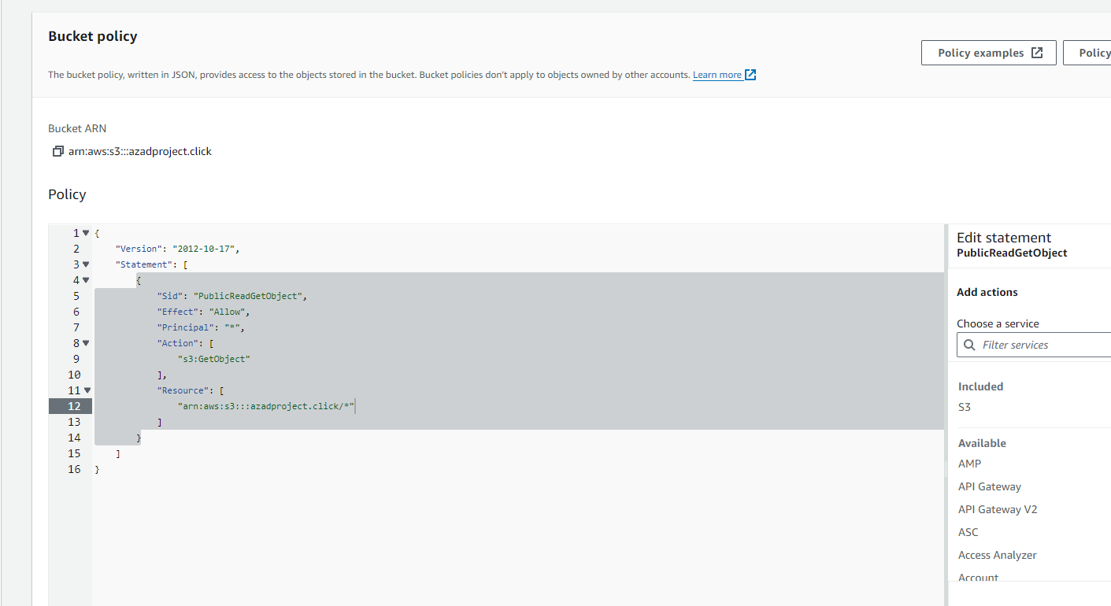

**When we open the website we see that it doesn't have the url we brought from Route 53.**

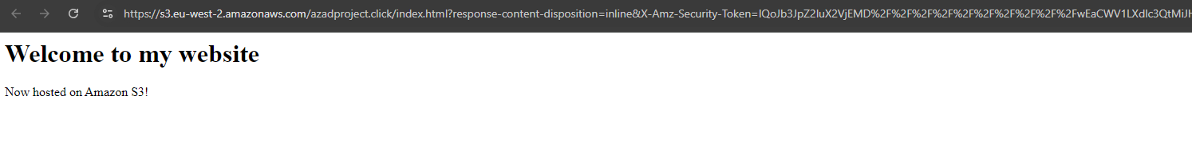

**We now have to go back to route 53 and create a new record that will be linked back to the S3 buckets.**

**Choose the simple routing policy!**

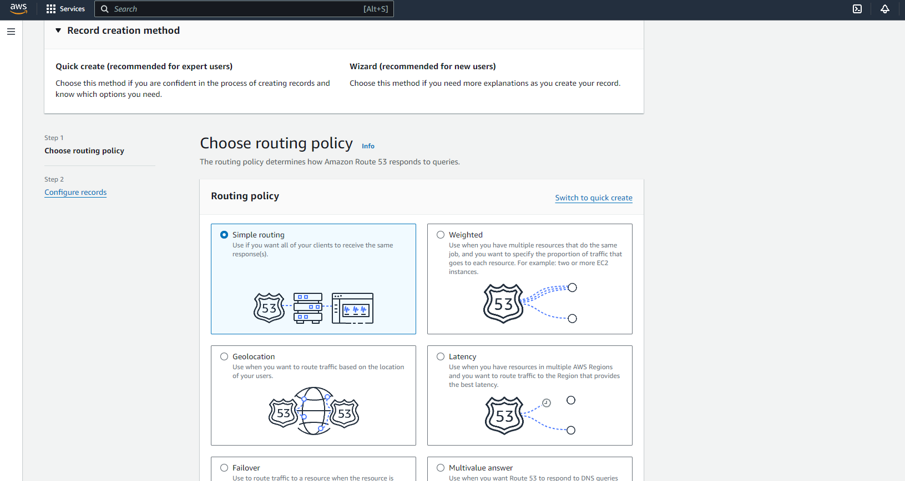

**The last step is to make sure you set your route traffic to the s3 website endpoint then pick the region and the s3 bucket you created would appear.**

